**46. Odd Digit Sum**

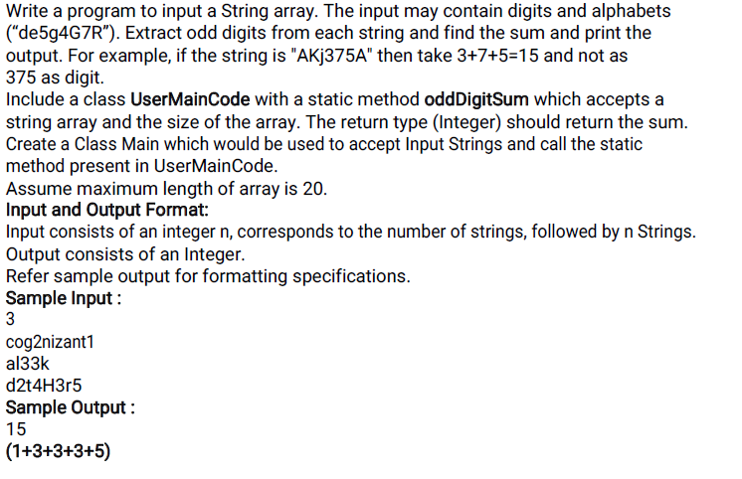

**Main**

**======**

**import java.util.*;**

**public class Main{**

**public static void main(String[] args){**

**}**

**UserMainCode**

**============**

**import java.util.*;**

**public class UserMainCode {**

**public static int oddDigitSum(String[] s1){**

**}}**

**47. Unique Number**

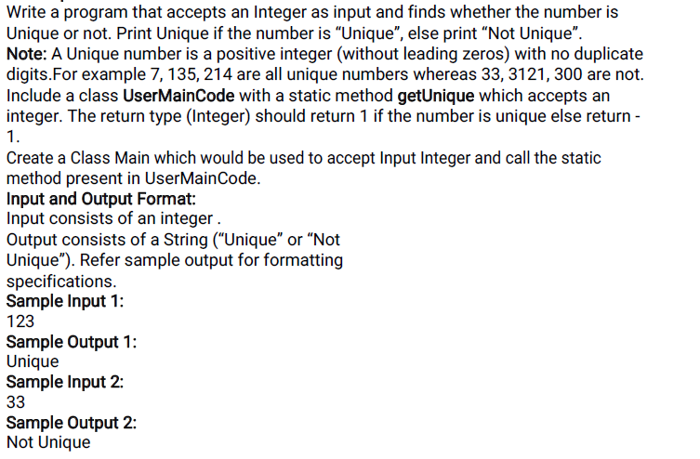

**Main**

**======**

**import java.util.*;**

**public class Main{**

**public static void main(String[] args){**

**}**

**UserMainCode**

**============**

**import java.util.*;**

**public class UserMainCode {**

**public static int getUnique(int n){**

**}}**

**48. Sum of Lowest marks**

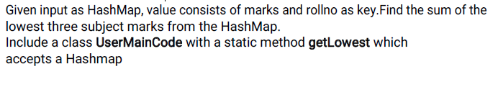

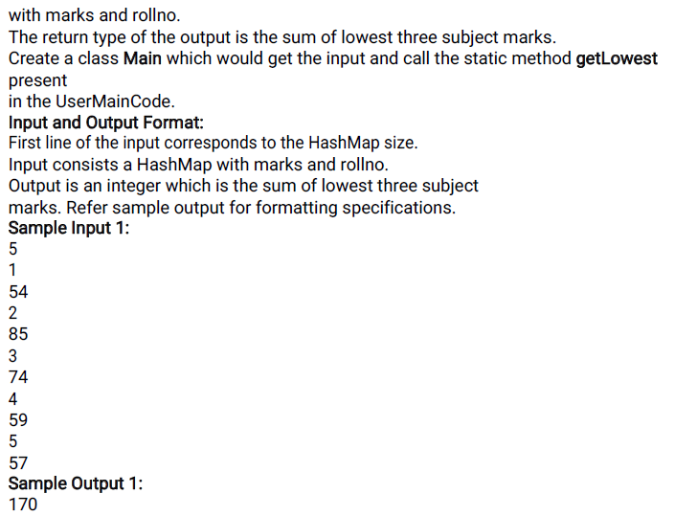

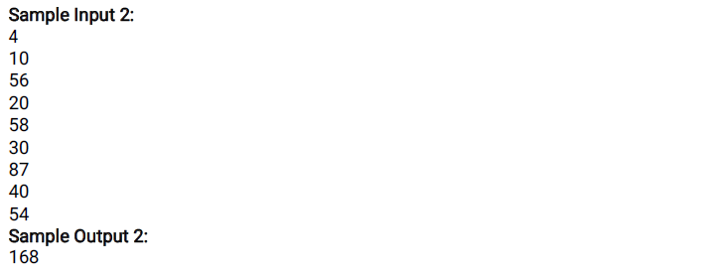

**Main**

**======**

**import java.util.*;**

**public class Main{**

**public static void main(String[] args){**

**}**

**UserMainCode**

**============**

**import java.util.*;**

**public class UserMainCode {**

**public static int getLowest(HashMap<Integer, Integer> h1){**

**}}**

**50. Repeating set of characters in a string**

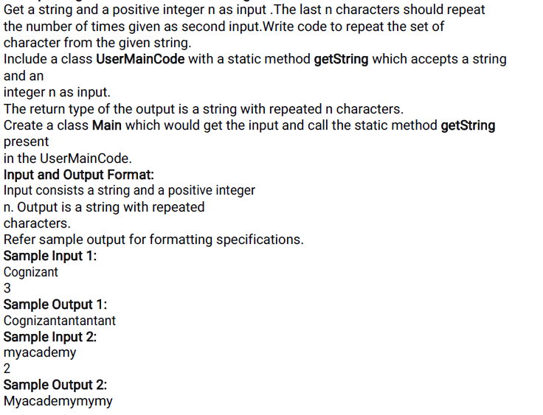

**Main**

**======**

**import java.util.*;**

**public class Main{**

**public static void main(String[] args){**

**}**

**UserMainCode**

**============**

**import java.util.*;**

**public class UserMainCode {**

**public static String getString(String input, int n){**

**}}**

**51. Finding the day of birth**

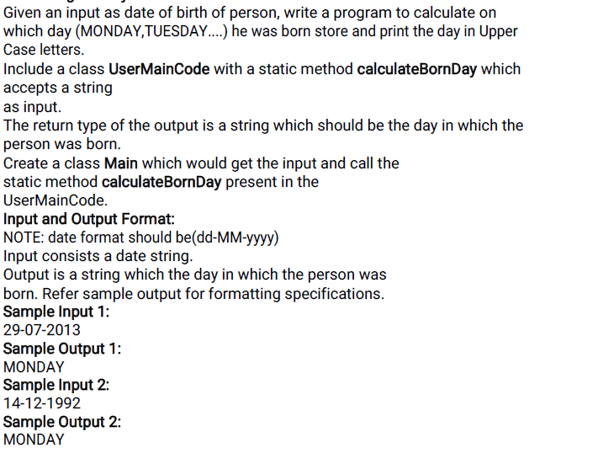

**Main**

**======**

**import java.util.*;**

**public class Main{**

**public static void main(String[] args){**

**}**

**UserMainCode**

**============**

**import java.util.*;**

**public class UserMainCode {**

**public static String calculateBornDay(String input){**

**}}**